5/26/2026
Shekhar Podutwar
26/5/2026
AWS Infrastructure Automation Using Terraform
AWS Infrastructure Automation

Contents

Document Version History……………………………….…………………………………………….1
Introduction…………………….…………………………………………………………………………….2
Objectives…………………….………………………..….………………………………………………….3
Tools & Technologies Used…………………………………………………………………………….4
Architecture Overview ………………………………………………………………………………….5
Step-by-Step Implementation …………………………………..………………………………….6
Conclusion…………………………………………………………………………………………………….7

Document Version History

Version Number | Date Modified | Author | Changes
Draft | 22/5/2026 | Shekhar | Draft Version

Introduction

This project focuses on automating AWS infrastructure provisioning using Terraform as an Infrastructure as Code (IaC) tool. The main objective was to create and manage AWS EC2 instances automatically through reusable Terraform configuration files instead of manual setup from the AWS Management Console. The project helps improve deployment speed, consistency, scalability, and infrastructure management efficiency.

Objectives

- Automate AWS EC2 instance provisioning using Terraform.
- Implement Infrastructure as Code (IaC) for reusable and scalable infrastructure deployment.
- Reduce manual configuration efforts and improve deployment consistency.
- Manage AWS resources efficiently using Terraform configuration files.
- Enable faster server deployment and infrastructure management in AWS Cloud

Tools and Technologies
Category | Tools / Technologies
Cloud Platform | Amazon Web Services (AWS)
IaC Tool | Terraform
Compute Service | Amazon EC2
Operating System | Linux (Amazon Linux / Ubuntu)
CLI Tools | AWS CLI, Terraform CLI
Programming/Scripting | HCL (HashiCorp Configuration Language), Bash
SSH Access | PuTTY / SSH

Architecture Overview
Aws ec2 instance
↓
Terraform installation
↓
Manually IAM Server
↓
Manually create access key
↓
Terraform Configuration Files (main.tf)
↓
Terraform Putty Commands (init, plan, apply)
↓
AWS Provider Authentication
↓
AWS Cloud Infrastructure
↓
EC2 Instance Provisioning
↓
Server Access via SSH
Step-by-Step Implementation

Step 1. Create an EC2 Instance
- Go to Amazon Web Services console
- Open EC2 Dashboard • Click Launch Instance o Choose:
AMI: Amazon Linux (or Amazon Linux 2)
Instance type: t3.micro (free tier)
- Create / select Key Pair (.ppk file)
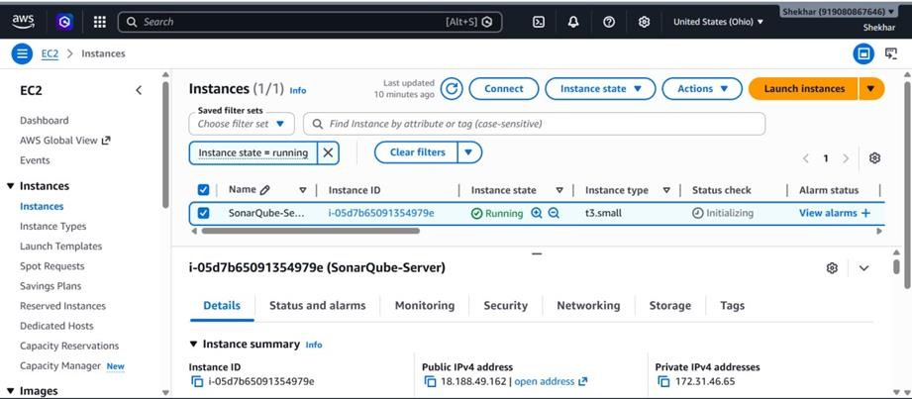

Step 2. Connect to Instance (PuTTY)
- Convert .ppk using PuTTYgen
- Open PuTTY

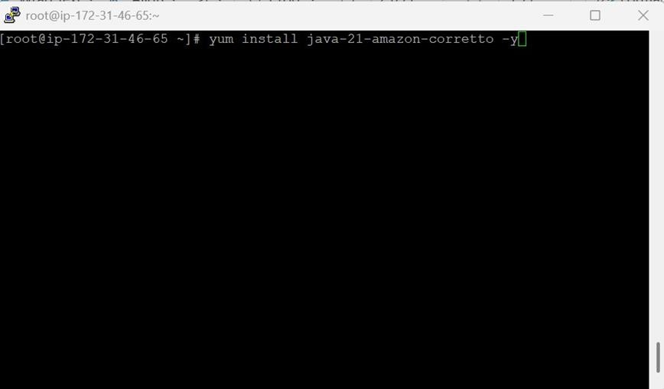

Step 3. Install Terraform
- Installing terraform search on browser
- Select operating machine as per your operating system (Instance)
- we are using Linux
- sudo yum install -y yum-utils shadow-utils
- sudo yum-config-manager --add-repo https://rpm.releases.hashicorp.com/AmazonLinux/hashicorp.repo
- sudo yum install terraform
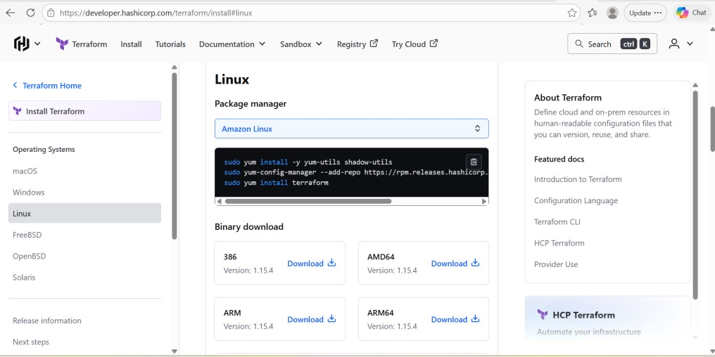

Step 4. Working in Terraform
- Create user in IAM service
- Then click on IAM users and create user
- Set permission as per need
- Next then create
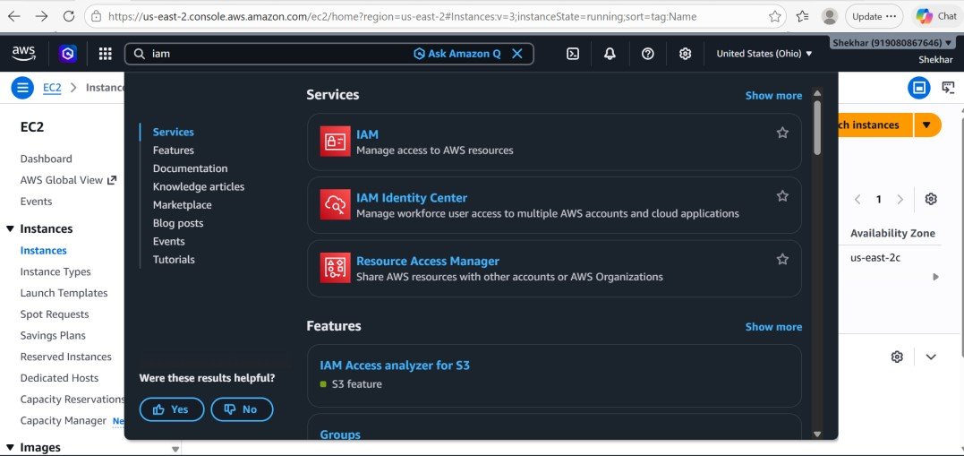

Step 5. Create an access key
- Now you can use your IAM user
- Go to recently created IAM user and click on
- Security credentials--> Access Keys--> Create access key
- Select CLI
- select confirmation check box
- Then next
- Now you can access your access key and secret access key
- Putty- aws configure
- Add access key and secret access key • Default region
- We select Mumbai region (ap-south-1)
- Output format text
- Now you can work in terraform
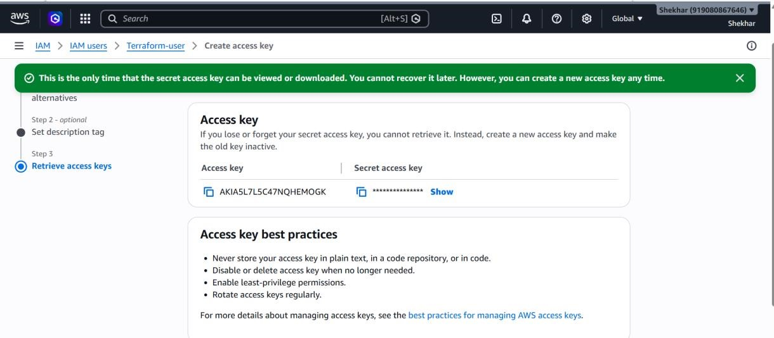

Step 6. Create an instance
- Create a directory for storing the configuration files.
- Creating directory mkdir /infra
- Cd /infra
- Inside the folder write a file in HCL language(filename.tf)
- Inside this file mentions the requirement.
- Goto Mumbai region and create keypair manually
- Create file cat> main.tf
- Modify then add code

- (To create 1 instance)

vim main.tf //file name

provider "aws" {
region = "ap-south-1" //server mumbai
}
resource "aws_instance" "myec2" { //variable name
ami = "ami-0ff5003538b60d5ec" //AMI id
instance_type = "t3.micro"
key_name = "instance1-keypair"
//manually create keypair in Mumbai region

tags = {
Name = "instance1" //instance name
}
}

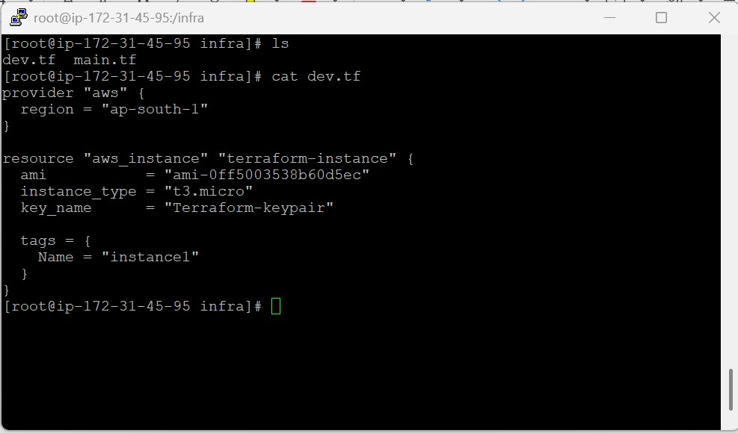

Step 7. Now you can work in terraform
- IAM user--> add permissions-->attach policy directly--> ec2fullaccess
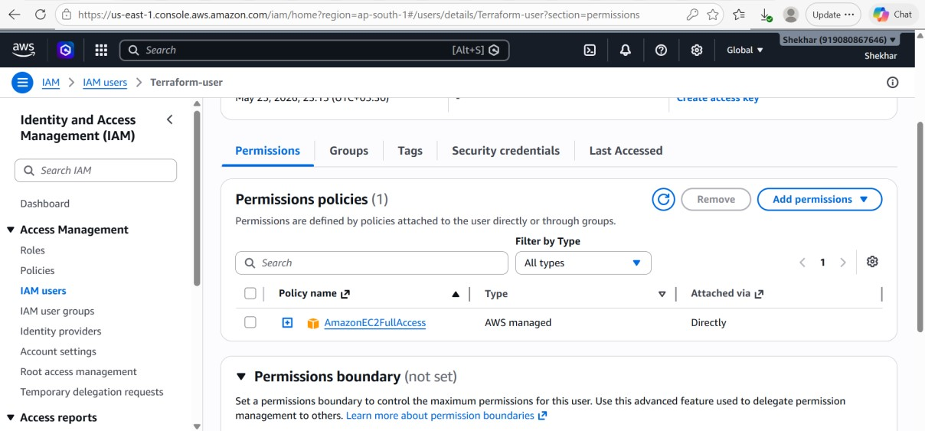

Step 8. Now you can follow the given command
- Terraform init
- Terraform plan
- Terraform apply
- Now see instance created in Mumbai region using terraform.
- Create a one file in server terraform.tfstate
- Vim terraform.tfstate (you see server info) (:q)

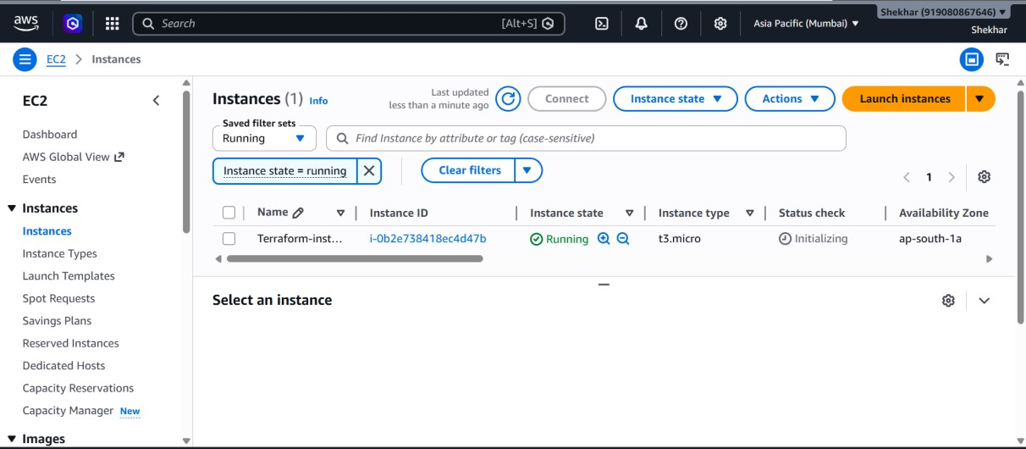

Step 9. Backup data
- Terraform destroy
- If you want to delete server then use
- After destroying a server, the server terraform.tfstate.backup file is created.
- You can access the destroy data
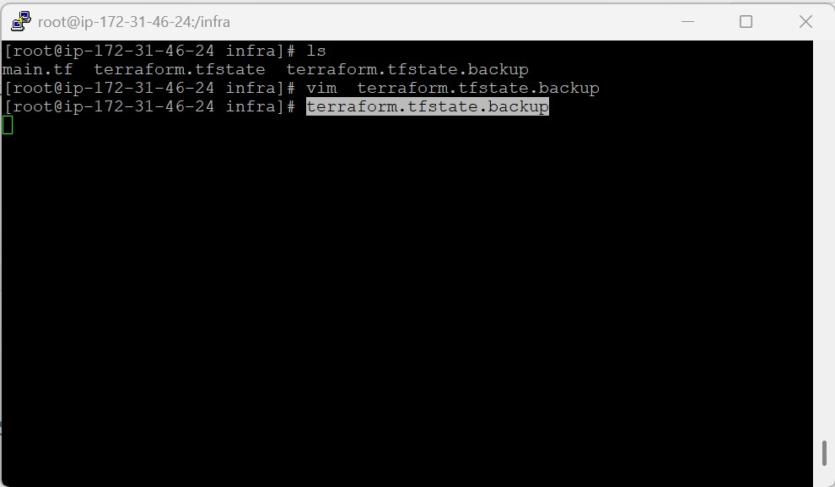

Conclusion
This project successfully demonstrated the implementation of Infrastructure as Code (IaC) using Terraform for automating AWS infrastructure provisioning. By integrating Terraform with Amazon Web Services, EC2 instances were created and managed efficiently through reusable configuration files. The automation process reduced manual intervention, improved deployment consistency, and enabled faster infrastructure setup. This project also provided practical experience in cloud infrastructure management, terraform workflows, and AWS resource provisioning, making infrastructure deployment more scalable, reliable, and maintainable.

